

**Usuarios** (Todos usan la misma contraseña: **info2017tegra)**

* + coordinador_interno@interactin.com
  + coordinador_externo@interactin.com
  + estudiante@interactin.com
  + Validador1@interactin.com
  + Validador2@interactin.com
  + Validador3@interactin.com

**URL de InterActin:** http://interactin.com

**Rutas:**

**Pagina de bienvenida:** http://interactin.com/

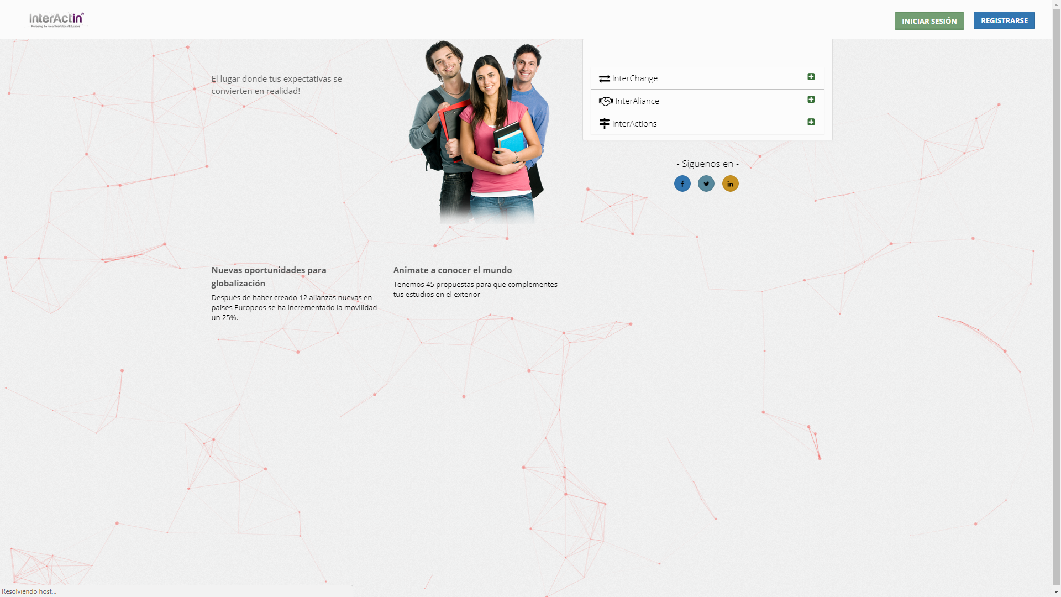

**Login:** http://interactin.com/login

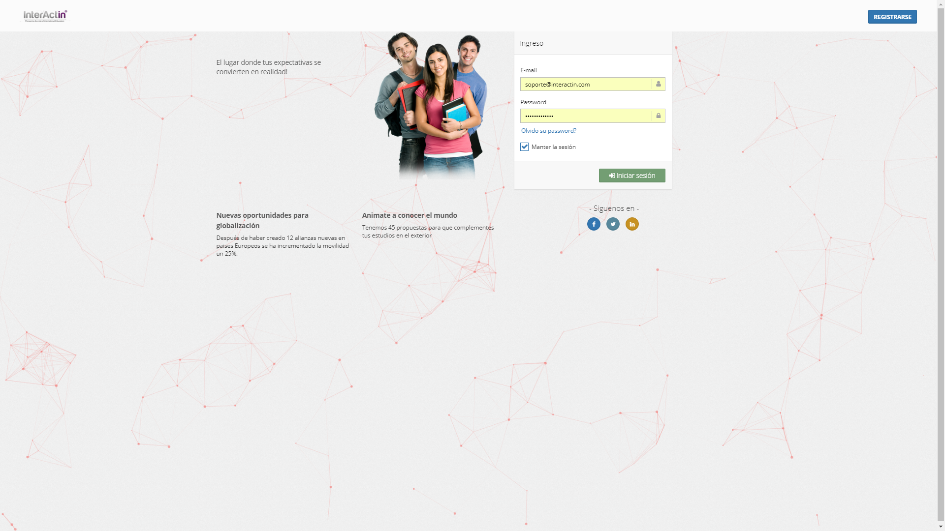

**Registro:** http://interactin.com/register

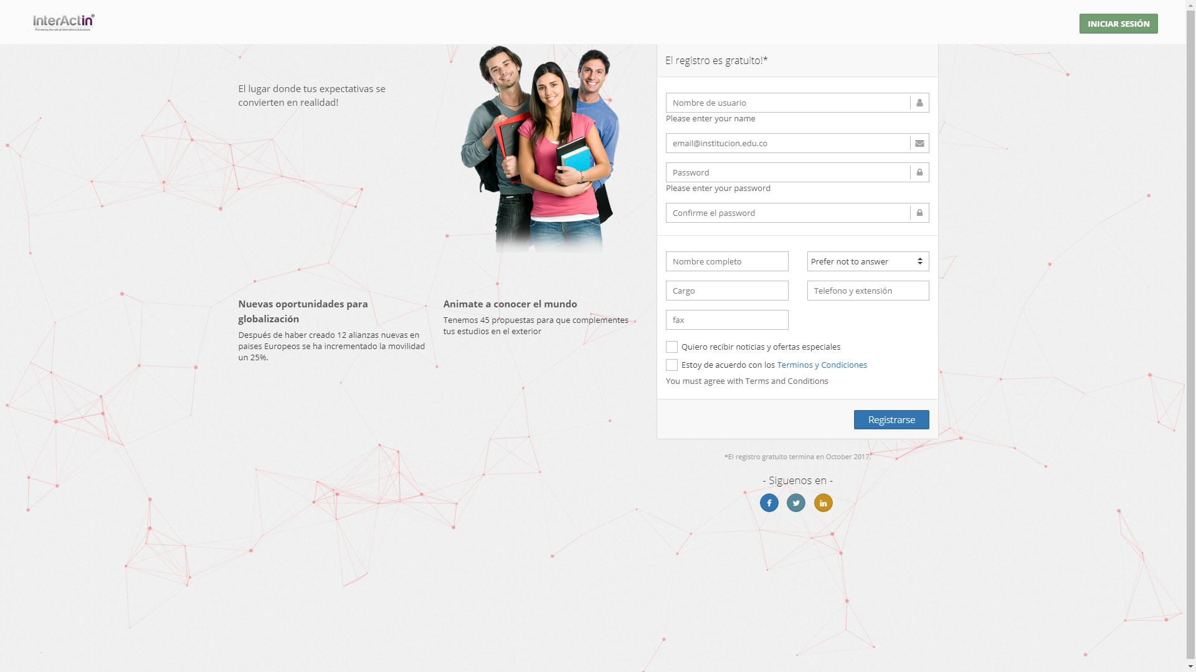

**Home:** http://interactin.com/home

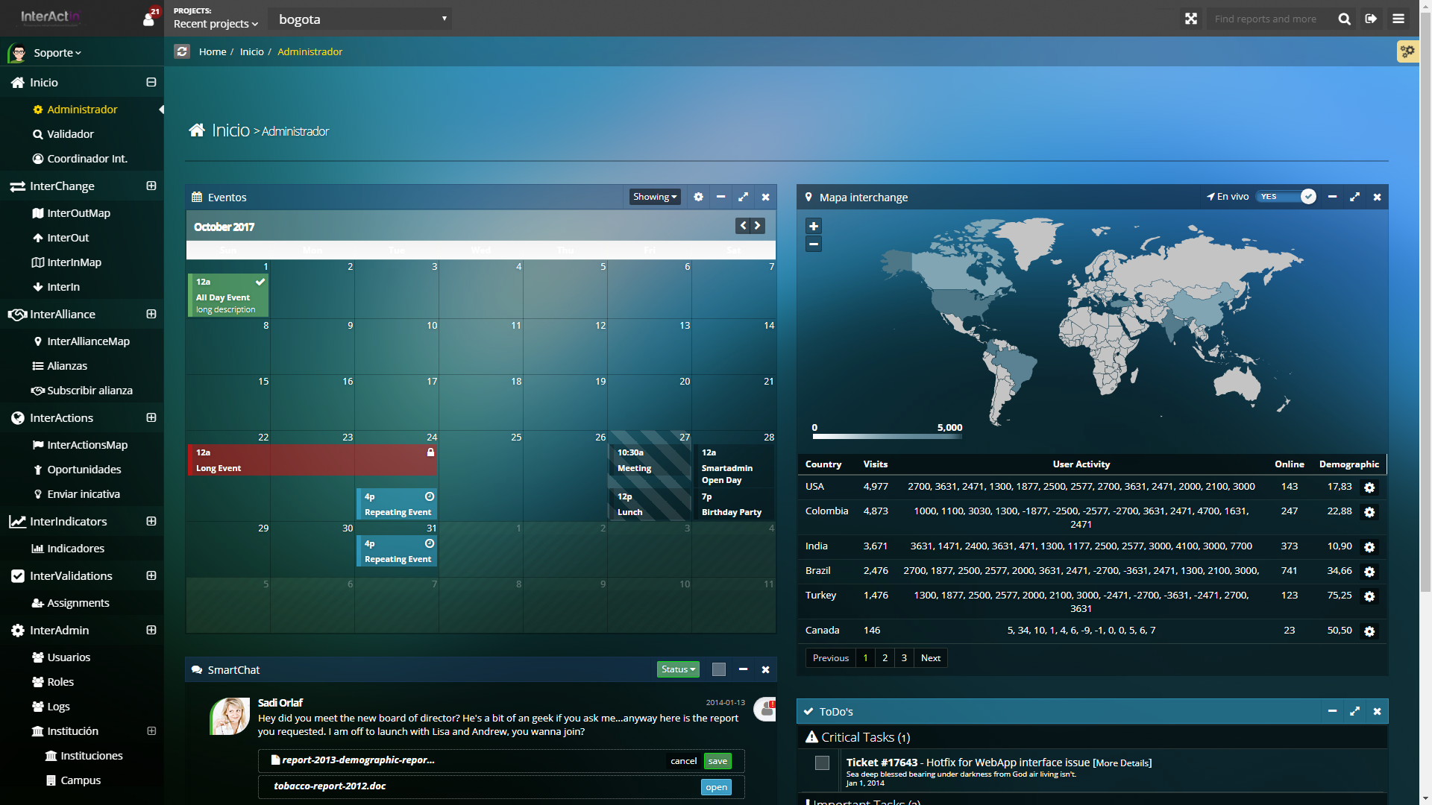

**InterAdmin→Instituciones:** http://interactin.com/admin/institutions

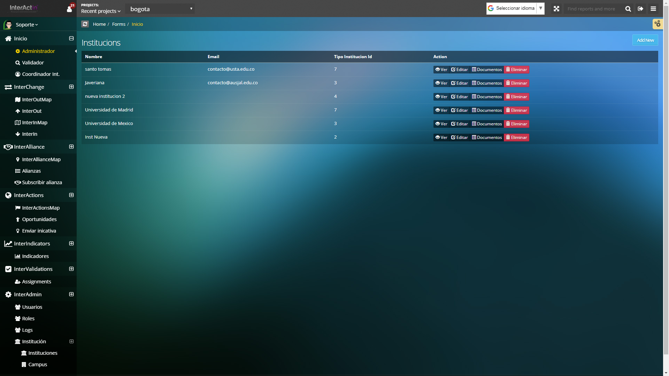

**InterAdmin→Campus:** http://interactin.com/admin/campus



**InterAdmin→Facultades:** http://interactin.com/admin/faculties

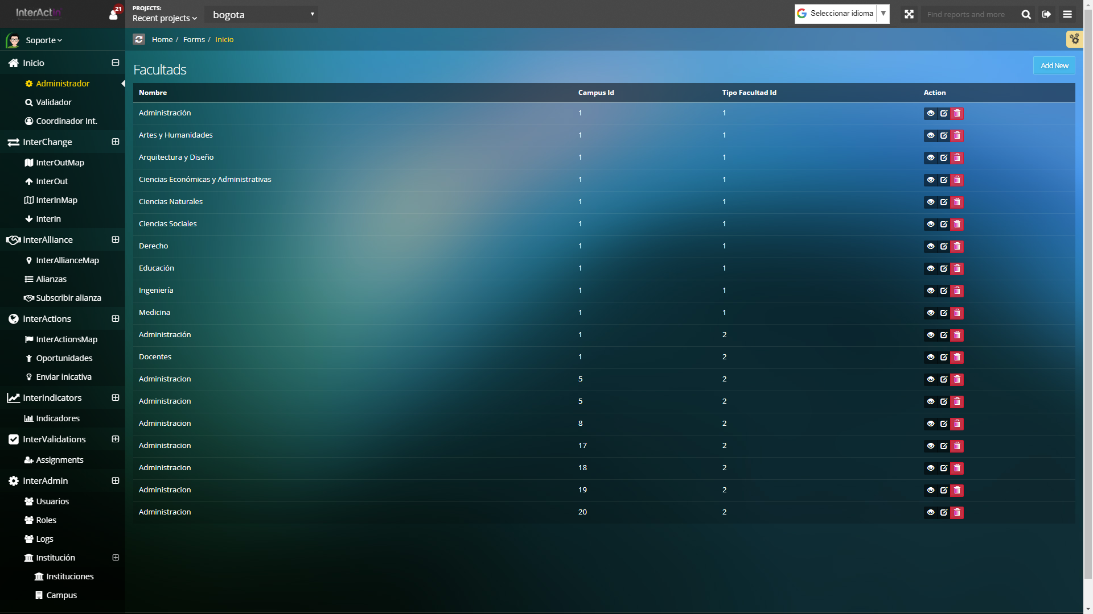

**InterAdmin→Programas:**  http://interactin.com/admin/programs



**InterAdmin→Asignaturas:** http://interactin.com/admin/subjects

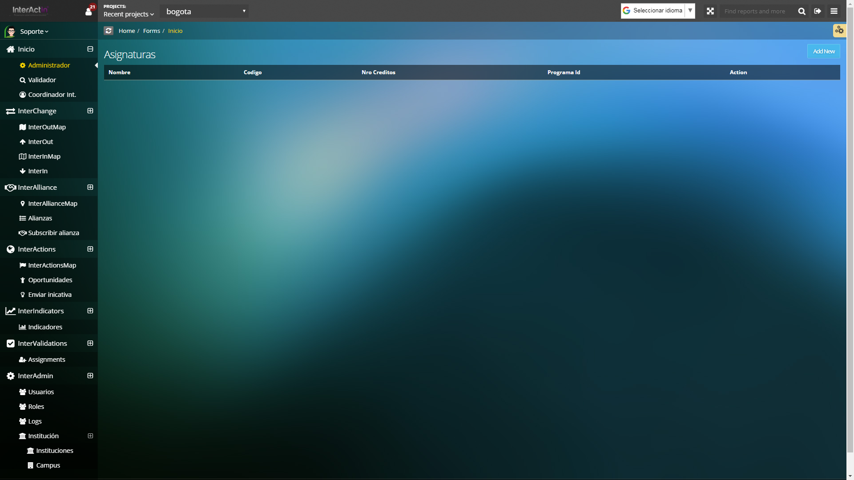

**InterAlliance→InterAllianceMap:** http://interactin.com/interalliances/map

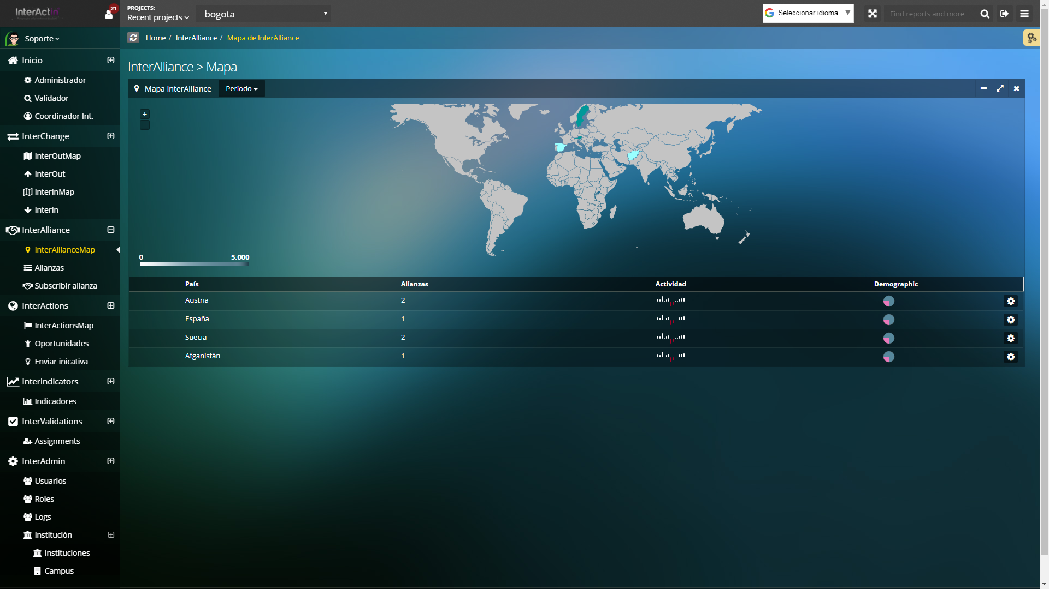

**InterAlliance→Alianzas:** http://interactin.com/interalliances/

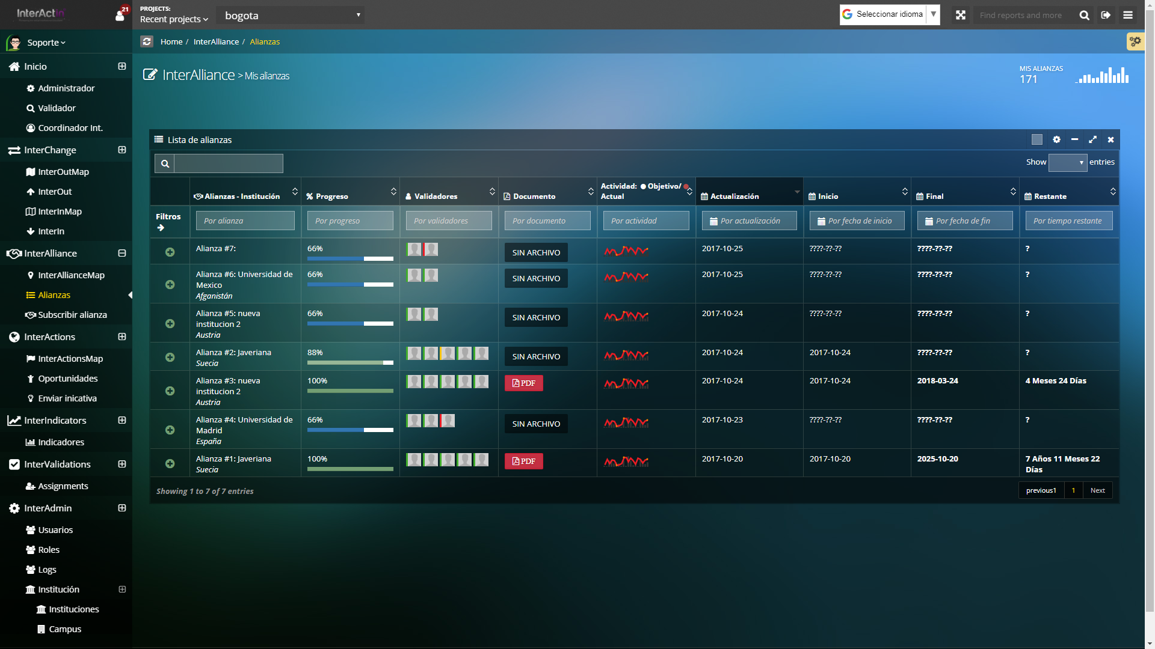

**InterAlliance→Subscribir Alianza:** http://interactin.com/interalliances/subscribe/origin

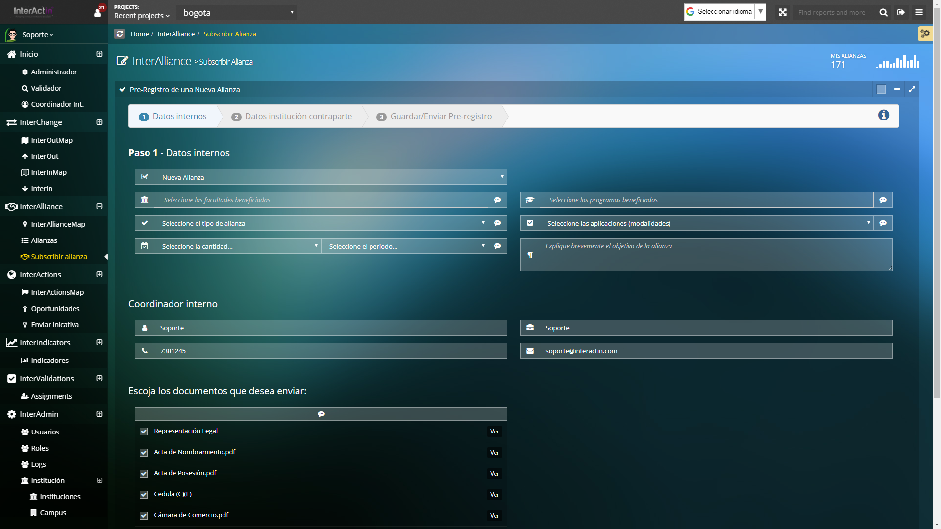

**InterChange→InterOutMap:** http://interactin.com/interchanges/interout/map

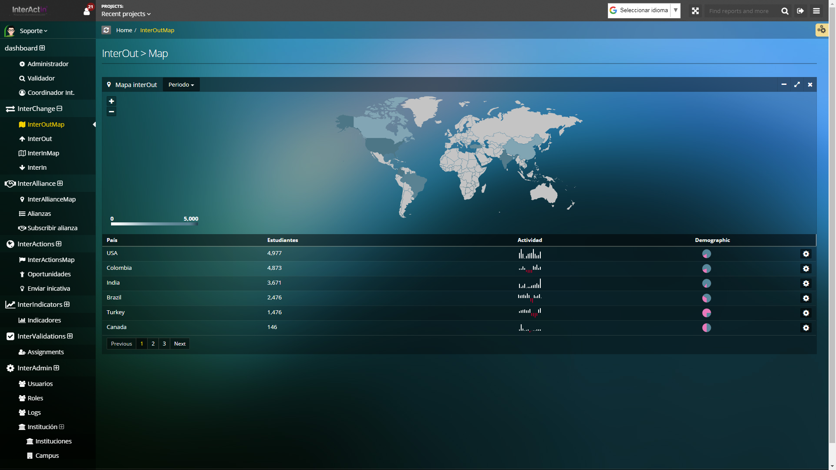

**InterChange→InterOut:** http://interactin.com/interchanges/interout/create

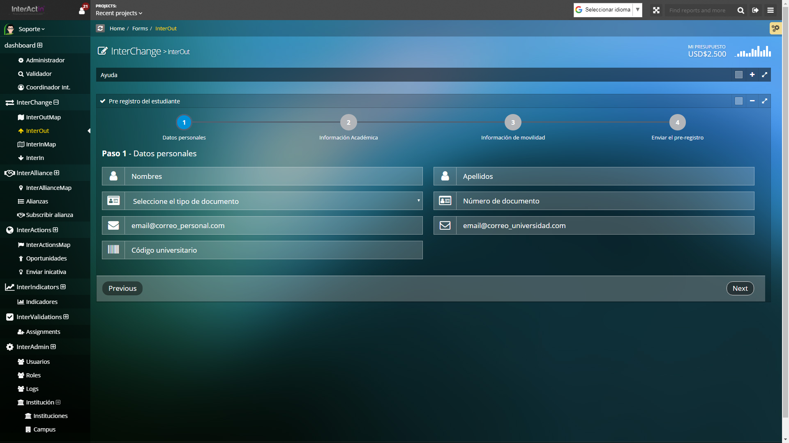

**InterChange→InterInMap:** http://interactin.com/interchanges/interin/map

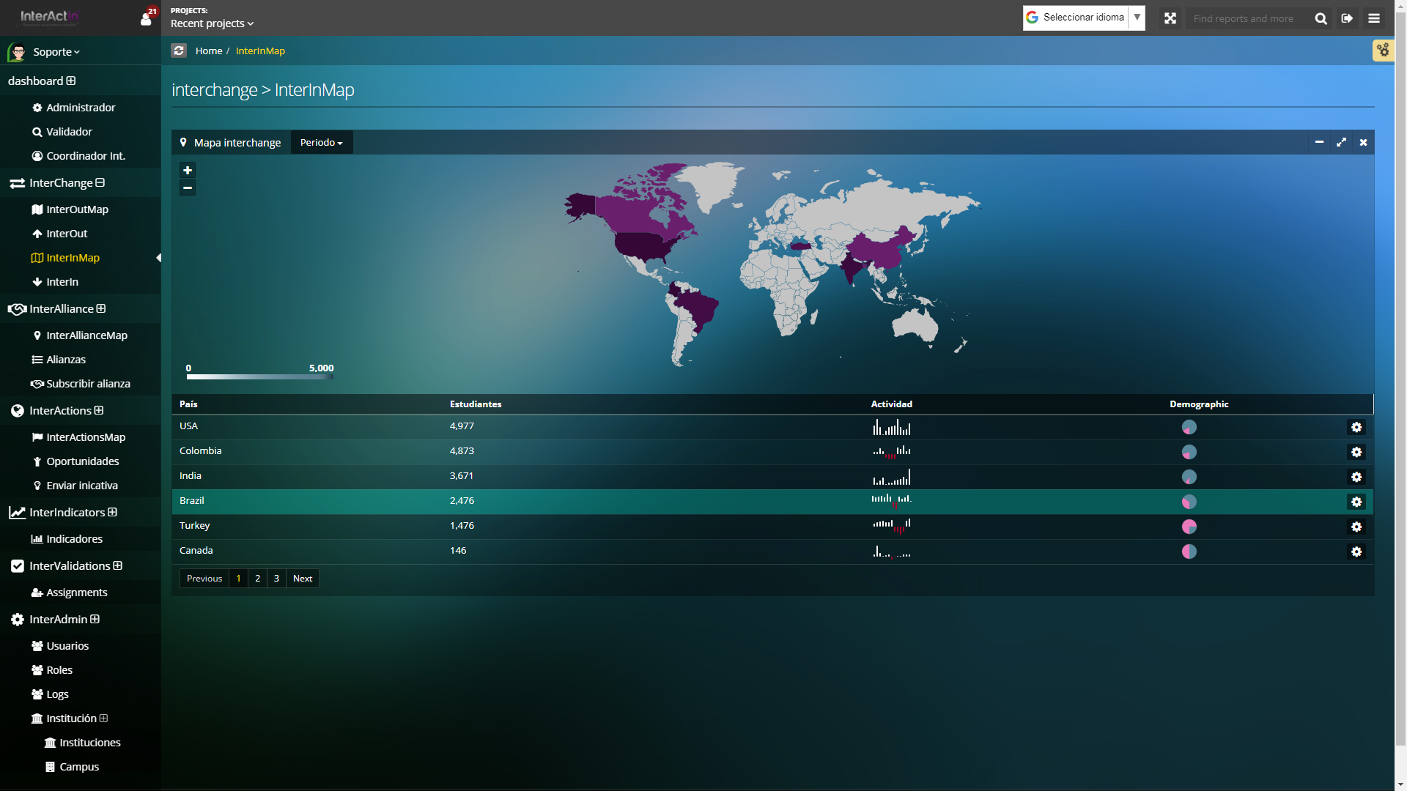

**InterChange→InterIn:**  http://interactin.com/interchanges/interin/create

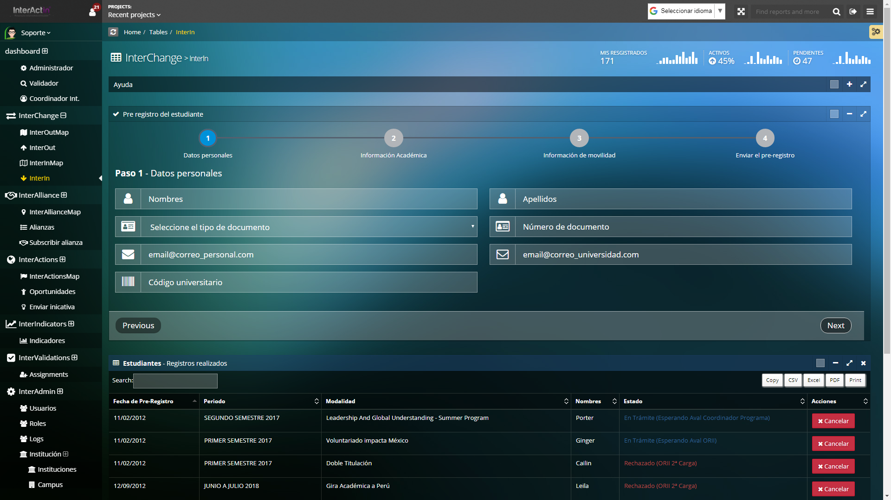

**InterActions→InterActionsMap:**  http://interactin.com/interactions/map

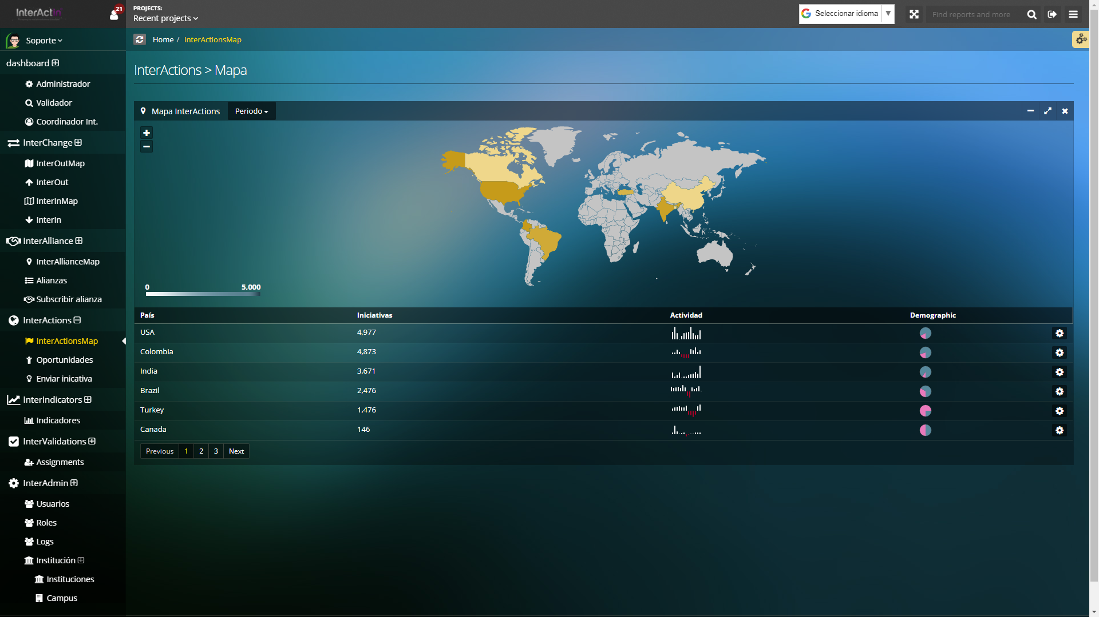

**InterActions→Oportunidades:** http://interactin.com/interactions/opportunities

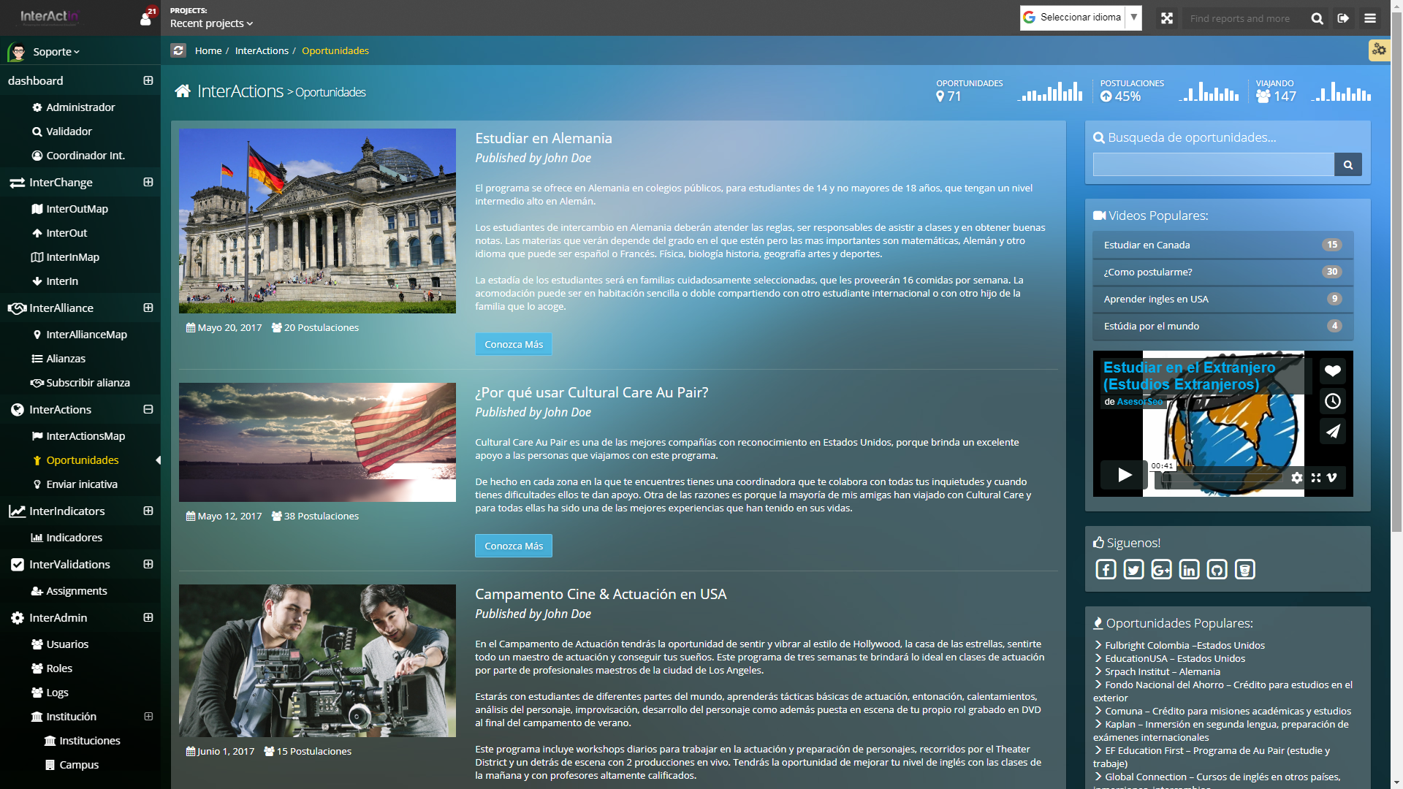

**InterActions→Enviar Iniciativa:** http://interactin.com/interactions/send_initiative

